Lab 01: IAM
Create user
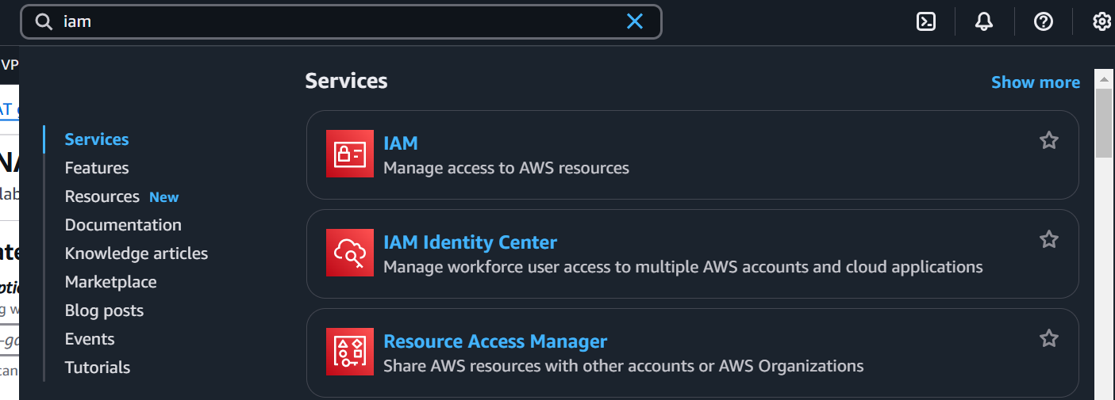

Click on users, and create user
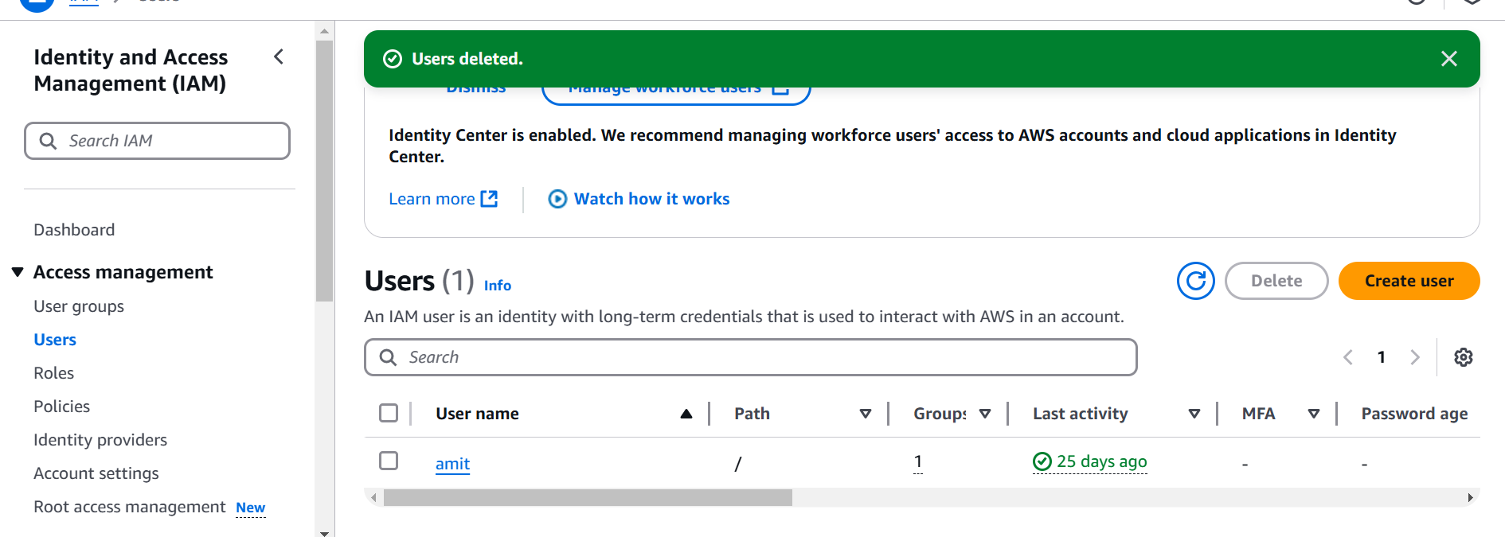
Provide below option
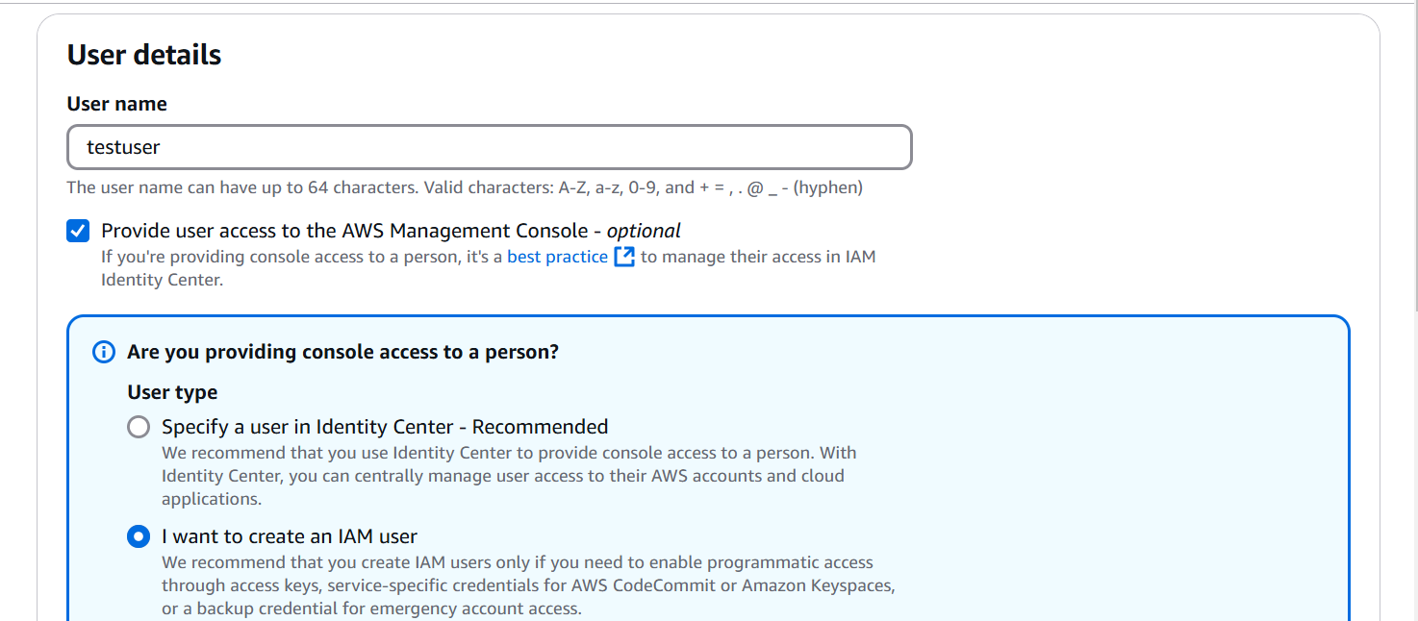

Select auto generated password
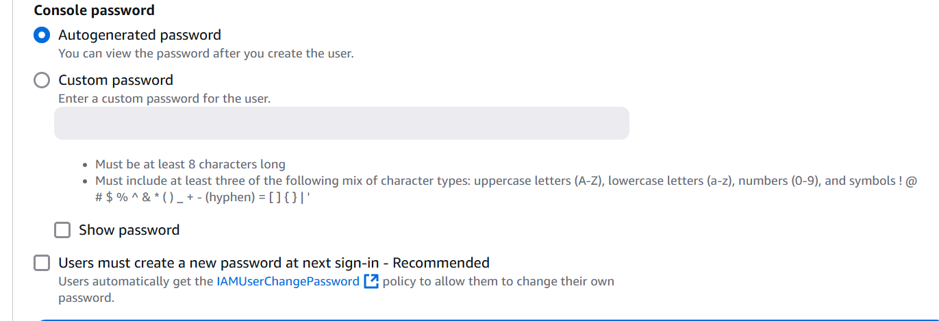

Add user to group option

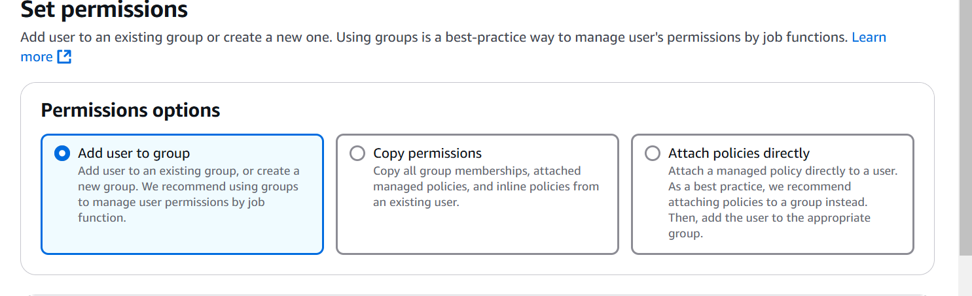

Note: Don’t map the user to any group

Copy below information in your notepad

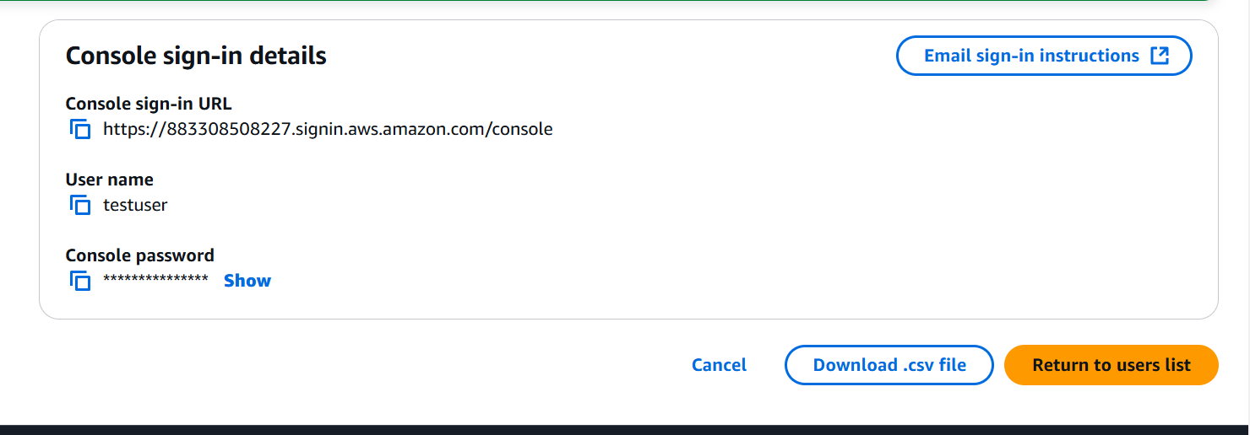

Open Private/incognito mode
Access through url provided above
After login you will get error
